**Homework6: Clustering with Gaussian Mixture Model**

In order to implement Gaussian Mixture Model, I had to understand how clustering worked. One of the basic approaches to solve cluster analysis problem is K-means. K-means algorithm partitions the data into K clusters but this approach had some drawbacks so gaussian mixture model was introduced. A probabilistic approach to cluster many of these problems. We use each cluster by its mean, covariance, and weight. The mean points were computed from our random data point values. Covariance, identified from our matrix. Finally, the weights were split into equal values according to our K. I have tried to comment out most of my code for better understanding. Also, in my implementation I have referenced a similar solution how to approach this problem but the code is not similar. It just gave me some ideas. You can see my results and my reference below.

**Plot Results:**

**Visualization: a Cross Section**

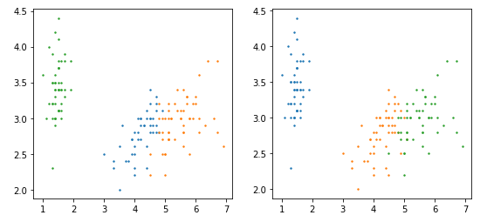

**Visualization: PCA Projection**

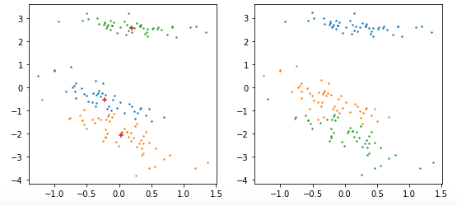

**References:**

https://medium.com/clustering-with-gaussian-mixture-model/clustering-with-gaussian-mixture-model-c695b6cd60da

<https://stackoverflow.com/questions/52887562/how-to-implement-gmm-clustering-em-algorighmexpectation-maximisation-algorithm>